Windows Azure Pack Storage Sample

Version 0.1 Features 1

Admin Experience 1

Tenant Experience 3

Roadmap 5

Feedback 6

# Version 0.1 Features

This is an overview of the features available in version 0.1 of storage sample. Except for some basic code clean up (which is planned to be taken up along with v0.4), it is all good. You can browse / download the sample code from this [Git Project](https://github.com/terawe/WindowsAzurePack). Providing the screen captures, so that everyone can easily have an expectation on the feature set of v0.1.

## Admin Experience

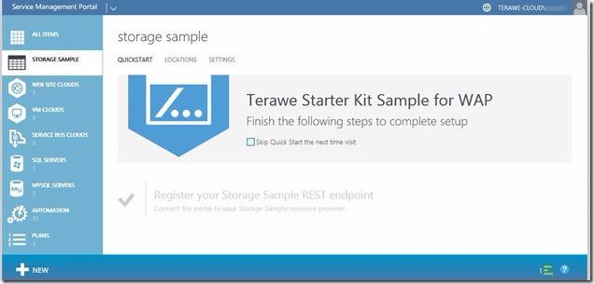

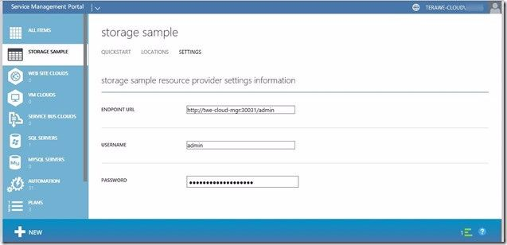

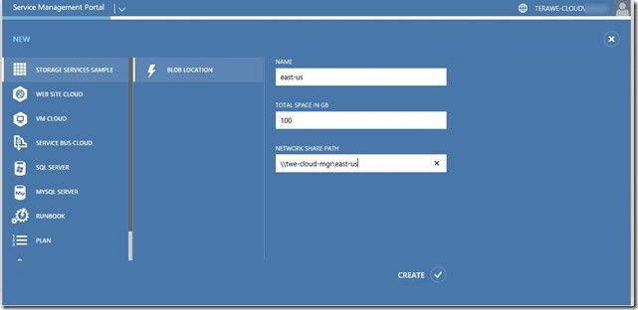

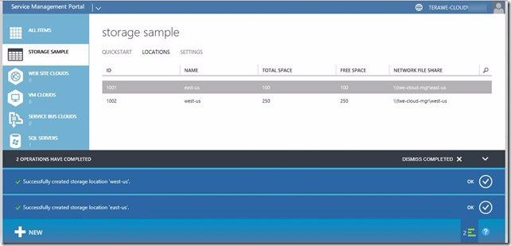

## Tenant Experience

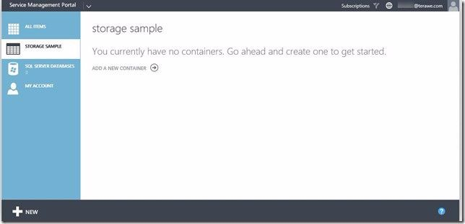

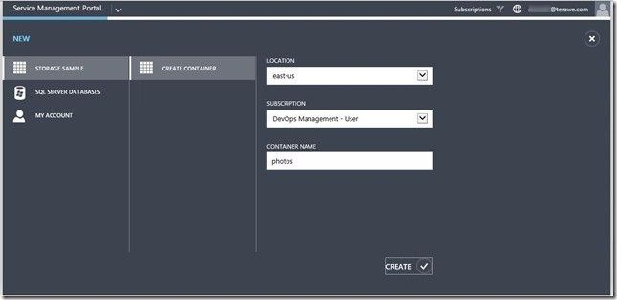

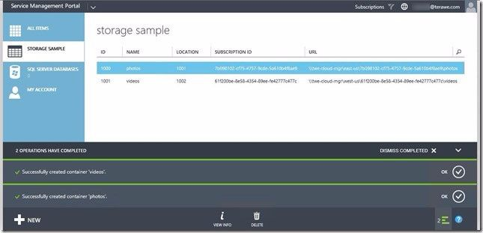

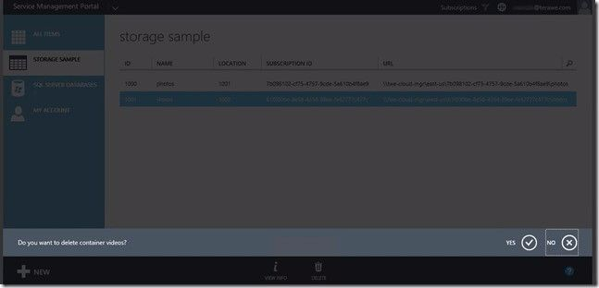

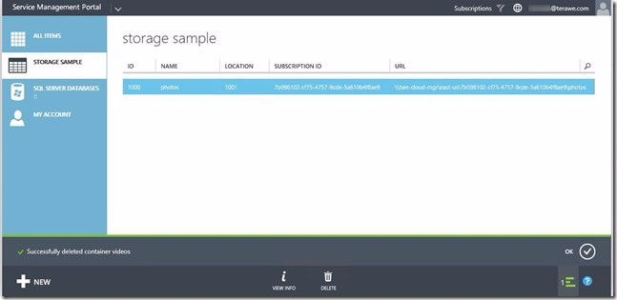

# Roadmap

If you would like to see what is coming next, here is an overview.

After looking at various resource provider implementation (Hello World and other content script files with in the deployment) to understand various approaches, in addition to the resources available on MSDN, we got to a good state to start the development of storage sample for Windows Azure Pack. We are thinking of following as the various features for the sample.

* 0.1 – Basic sample with minimal capabilities (with in-memory data provider)
  + Admin should be able to create storage locations and map it to physical network location
  + Tenant should be able to create containers with in specific locations
  + Tenant should be able to delete container
* 0.2 – Tenant should be able to upload files to container
  + Note: No plans to support folders with in a container
* 0.3 – WAP Drive
  + A standalone web application to interact directly with Tenant API and demonstrate a photo album
* 0.4 – Stabilize
  + Clean up code, comments added as required.
  + Refactor API library with clean web-api implementation
* 0.5 – Implement usage
* 0.6 – Implement quota
* 0.7 – Implement database data provider with updates to setup
* 0.8 – Implement custom PowerShell commands to enable tenant operations

Mostly we plan to get subsequent minor versions made available regularly (effort for each is around a week) with v0.1 available since around 8/17/2014.

# Feedback

If you have any questions on the code sample, need help with some specific scenarios, you can reach us through [MSDN forum for WAP](http://social.msdn.microsoft.com/Forums/windowsazure/en-US/home?forum=windowsazurepack). We follow the forum continuously.